IPR MANAGEMENT
IP Commercialization
Turning protected knowledge into revenue
A complete study companion covering the economics, law, strategy and practice of commercializing intellectual property — built from the course slide deck and from Granstrand's chapter on technology and commercialization strategies, with every figure and statistic verified against primary sources.

What is inside
Sixteen parts running from first principles to valuation, with ten original diagrams.
Every number checked against USPTO, WIPO, AUTM, Ocean Tomo, court judgments and company reports. Where the lecture slides are wrong, Part 15 says so and gives the corrected figure.
Written to be remembered — one idea per section, a spine you can recite, summary tables, and twenty self-test questions at the end.

Data current to the WIPO World Intellectual Property Indicators 2025 release (published 12 November 2025) and USPTO FY2024 statistics.
Contents
PART 1 Foundations: what commercialization is and why it matters
1.1 The one-sentence definition
1.2 The patent bargain, and where it came from
1.3 The three facts that make this subject urgent
PART 2 The corporate innovation ecosystem
2.1 The circuit
2.2 Why legal sits at every gate
2.3 Seven conditions for a system that actually works
PART 3 The strategy menu: acquiring and exploiting technology
3.1 The integration ladder
3.2 Seven ways to acquire technology
3.3 Five ways to exploit it
3.4 Complementary assets — the reason you cannot always go it alone
3.5 The leakage problem
PART 4 Four ways to turn technology into profit
4.1 Run-in, lock-in, lock-out, squeeze-out
4.2 What firms actually rely on — the evidence
4.3 The limits of patents
PART 5 The funnel and the valley of death
PART 6 The commercialization process, step by step
6.1 The eight-stage pipeline
6.2 Freedom to operate, due diligence and the IP audit
PART 7 Patent strategy: sequence, claims and portfolio
7.1 The filing sequence
7.2 Claim architecture
7.3 Blanketing, fencing and pruning
PART 8 Licensing: the main engine of IP revenue
8.1 Types of licence
8.2 The terms that decide the money
8.3 The negotiation
8.4 The licensing-revenue rule of thumb
8.5 Royalty base, royalty rate and stacking
PART 9 Cross-licensing, pools and standards
9.1 From deadlock to mutual access
9.2 Bundling and portfolio licensing
9.3 Standards, SEPs and FRAND
9.4 Two cases: VHS and GSM
9.5 Huawei: the modern template
PART 10 Valuation
10.1 Three families of method
10.2 The 25% rule and why courts rejected it
10.3 Georgia-Pacific, Monte Carlo, and the structural point
PART 11 Who owns the invention? A comparison of four systems
PART 12 Publicly funded research: Bayh-Dole and after
12.1 The Act
12.2 March-in rights
12.3 The system in aggregate
12.4 Public research organisations have different priorities
PART 13 Diversification and the economies of scale, scope and speed
13.1 The staircase
13.2 Speed to market, technology and patent
13.3 Canon, NEC and the power of a vision
PART 14 Alternatives and adjacent routes
14.1 Trade secrets versus patents
14.2 Open innovation and patent pledges
14.3 Trademarks, copyright and franchising
14.4 The Indian context
14.5 What is changing now
PART 15 Corrections to the lecture slides
PART 16 Memory aids and self-test
16.1 The spine
16.2 Summary tables
16.3 Twenty questions
PART 1

Foundations

1.1 The one-sentence definition
IP commercialization is the set of activities that converts a legally protected intangible asset into money or into competitive advantage. Everything else in this subject is detail hanging off that sentence. An invention sitting in a laboratory notebook has no economic value. A granted patent framed on a wall has no economic value either. Value appears only at the moment the protected knowledge is attached to something a customer pays for — a product, a service, a process improvement, or a licence agreement that lets somebody else do the attaching.
This is worth stating plainly because the most common error in IP management is to treat protection as the goal. Protection is a cost. It is an investment made in the expectation of a later return, and like any investment it can be wasted. A firm that files a thousand patents and licenses none of them has spent a great deal of money to achieve nothing. The discipline of commercialization is the discipline of making sure the protection was worth buying.
Two consequences follow immediately. First, commercialization decisions and protection decisions are the same decision, taken at different moments. You decide where to file a patent by asking where your licensee will sell. You decide how broadly to claim by asking how a competitor would design around you. Second, the patent is only one instrument among several. Secrecy, speed to market, manufacturing cost, brand and distribution all perform the same economic function — they let the innovator capture the returns from the innovation instead of watching an imitator capture them. Part 4 sets these side by side.
The vocabulary you will keep meeting
Appropriability — the degree to which an innovator can capture the profits from an innovation rather than losing them to imitators. High appropriability regimes (pharmaceuticals) rely on patents; low ones (software, food service) rely on speed and brand.
Complementary assets — the manufacturing, distribution, service and brand capabilities you need in addition to the technology before anyone will pay for it. Teece's insight: whoever controls the scarce complementary asset usually captures most of the profit.
Exploitation (or technology exploitation) — Granstrand's term for commercialization. Used interchangeably in this document.
Freedom to operate (FTO) — whether you can sell your product without infringing someone else's live patent. Distinct from whether your own patent is valid.

1.2 The patent bargain, and where it came from
The whole system rests on a trade. The inventor discloses the invention publicly, in enough detail that a skilled person could reproduce it. In exchange, the state grants a time-limited right to exclude others — roughly twenty years from filing for a patent. Society gets the knowledge permanently; the inventor gets a temporary monopoly to earn a return. When the term expires the knowledge is free for everyone. Commercialization is simply the business of using that window well.
The American version of this bargain is almost as old as the republic, and four dates give it its architecture.

Date | What happened | Why it matters
1788 | The Constitution is ratified on 21 June. Article I, Section 8, Clause 8 empowers Congress to promote the progress of science and useful arts by securing, for limited times, exclusive rights to authors and inventors. | Intellectual property is written into the founding document itself — not added later as policy.
1790 | The Patent Act of 10 April creates the first federal patent law. Applications are examined by a board of three: Secretary of State Thomas Jefferson, Secretary of War Henry Knox, and Attorney General Edmund Randolph. On 31 July, Washington signs the first U.S. patent, to Samuel Hopkins, for a process of making potash. | Examination — not mere registration — is the American model from day one. For the next forty-six years the President personally signed every patent.
1836 | The Patent Act of 4 July establishes the numbering system still in use. Patent No. 1 issues on 13 July to Senator John Ruggles of Maine for traction wheels. | The modern professional patent office begins here.
1836 | On 15 December a fire destroys the records of roughly 9,957 unnumbered patents granted since 1790 — the 'X-patents'. | Only about 2,800 were ever reconstructed, from inventors' own copies. A reminder that the register is an administrative artefact, not a law of nature.

A footnote worth knowing: the USPTO and older historical markers describe Samuel Hopkins as being of Pittsford, Vermont. Archival research by the historian David Maxey in the 1990s concluded he was most probably a Philadelphia Quaker. Treat it as an open question rather than settled fact.

1.3 The three facts that make this subject urgent

Fact one — the pace of patenting has compressed dramatically
The first million U.S. utility patents took 121 years, arriving in 1911. The eleventh million took three years. That compression is the single clearest picture of how the knowledge economy has accelerated.

Milestone | Year reached | Years taken
1,000,000 | 1911 | 121
2,000,000 | 1935 | 24
3,000,000 | 1961 | 26
4,000,000 | 1976 | 15
5,000,000 | 1991 | 15
6,000,000 | 1999 | 8
7,000,000 | 2006 | 7
8,000,000 | 2011 | 5
9,000,000 | 2015 | 4
10,000,000 | 2018 | 3
11,000,000 | 2021 | 3

Patent 10,000,000 issued on 19 June 2018 to Raytheon (inventor Joseph Marron) for a coherent laser radar system. Patent 11,000,000 followed on 11 May 2021, assigned to 4C Medical Technologies for the AltaValve transcatheter mitral valve device. Annual U.S. output tells the same story: roughly 70,000 utility patents in 1976 against 321,020 utility patents in FY2024 (365,614 patents of all types, up 5.6 per cent).

Fact two — the world files more patents than ever, and Asia dominates
WIPO's World Intellectual Property Indicators 2025, published on 12 November 2025, reports 3.7 million patent applications filed worldwide in 2024, a 4.9 per cent increase and the fastest year-on-year growth since 2018. China's CNIPA alone received about 1.8 million applications — 49.1 per cent of the world total, growing 9 per cent. The USPTO received 603,194, the JPO 306,855, KIPO 246,245 and the EPO 199,402; the top five offices together account for 85.5 per cent of all filings and Asia for 70.1 per cent. By origin, China leads, followed by the United States (501,831) and Japan (419,132). India recorded 19.1 per cent growth — its sixth consecutive year of double-digit increase. Computer technology is now the largest published field at 13.2 per cent of the total. Only 18 per cent of inventors named on international applications are women.

Fact three — the market now values the intangible far above the tangible
Ocean Tomo's Intangible Asset Market Value study tracks the share of S&P 500 market capitalisation attributable to intangibles. It has risen from 17 per cent in 1975 to 32 per cent in 1985, 68 per cent in 1995, and approximately 92 per cent by the end of 2025 — a seventy-five percentage point shift the firm calls 'economic inversion'. Tangible assets now account for roughly eight per cent of the value of America's largest listed companies.
But — and this is the caveat that matters most for an IPR manager — the market prices patent quality, not patent count. The canonical study is Hall, Jaffe and Trajtenberg, Market Value and Patent Citations, RAND Journal of Economics 36(1), 2005, pp. 16–38. They estimate Tobin's q equations for U.S. firms over 1963–1995 using three ratios: R&D to assets, patents to R&D, and citations to patents. Each significantly affects market value, and an extra citation per patent is associated with roughly a 3 per cent increase in market value; firms averaging twenty or more citations per patent command a premium of about 54 per cent. The effect is strongest in drugs and weakest in computers and communications. Unpredictable citations matter more than the predictable component.
Tobin's q, in plain language
Tobin's q is a firm's market value divided by the replacement cost of its assets. If q is greater than 1, investors are paying more for the company than it would cost to rebuild its physical plant from scratch. That excess is the market's estimate of the intangibles: patents, know-how, brand, data, relationships.
The practical lesson. Patent value is extremely skewed — approximately log-normal — with a small share of patents carrying most of the value. A raw count of active patents is therefore a poor proxy for portfolio worth. The market rewards the tail, not the total. Manage your portfolio accordingly: find the few that matter, and prune the rest.
PART 2

The corporate innovation ecosystem
Before looking at individual strategies it helps to see the whole circuit, because commercialization is not a step at the end of R&D — it is the mechanism by which the money comes back round to fund the next cycle.
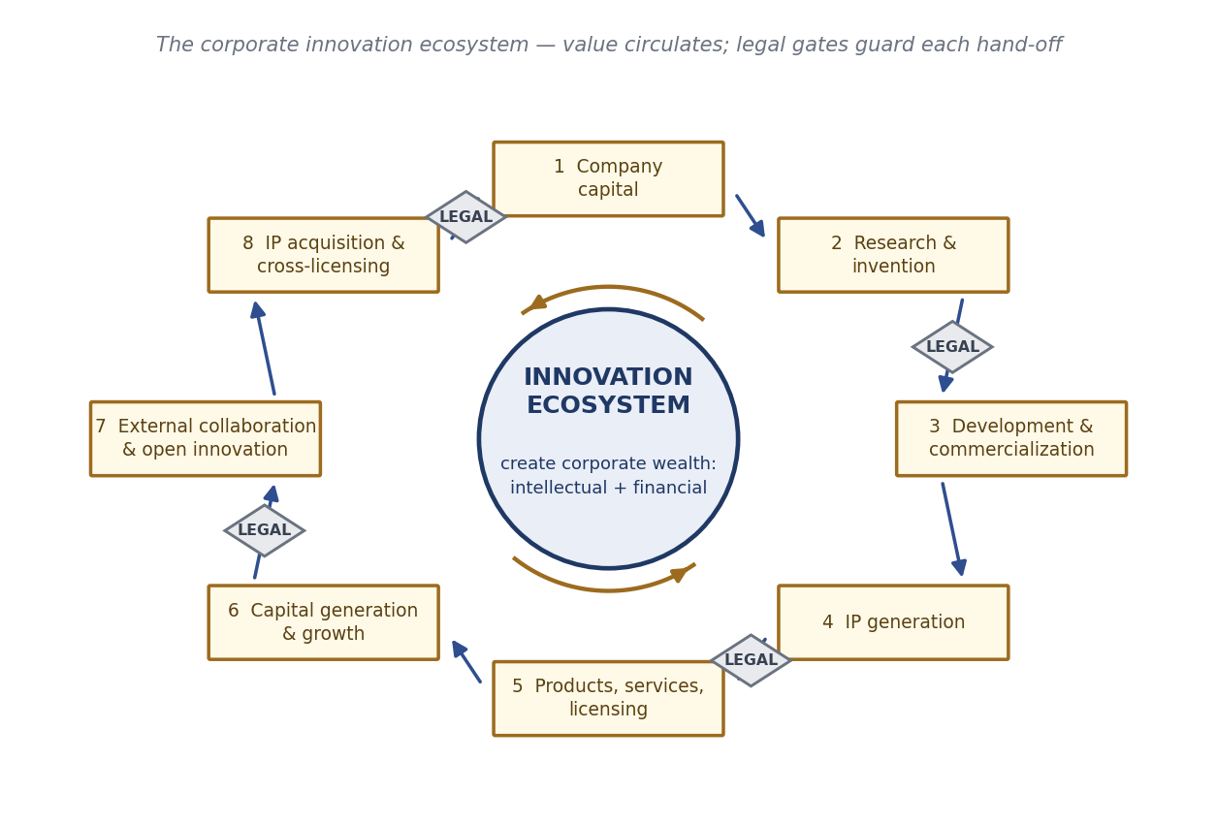
Figure 1 — The corporate innovation ecosystem. Capital funds research; research generates IP; IP protects products; products generate capital; capital funds research.

2.1 The circuit
Company capital is committed to research and invention. Promising results move into development and commercialization, and in parallel generate IP — patents, trademarks, designs, trade secrets. That IP protects the resulting products, services, processes and licensing programmes, which produce capital generation and growth. Some of that capital is reinvested directly; some funds external collaboration and open innovation; and some buys IP acquisition and cross-licensing, closing the loop back to capital. The stated goal at the centre is to create corporate wealth in two forms at once — intellectual and financial.
Two features of the diagram deserve emphasis. First, IP generation is not a terminal step. It feeds forward into products and sideways into cross-licensing, which is itself a way of acquiring technology you did not invent. Second, the loop is a loop. A firm that treats commercialization as the last stage of a linear pipeline will keep failing at it, because the information needed to commercialize well — which markets, which claims, which territories — has to travel backwards into the research stage.

2.2 Why legal sits at every gate
The diamonds in the diagram are decision gates where the legal and IP function has to be consulted before value passes to the next stage. This is the practical meaning of Cooper's stage-gate model applied to intangibles. At the research gate, legal checks novelty and freedom to operate. At the IP-generation gate, it decides patent versus trade secret, and drafts the claims. At the product gate, it clears the launch and checks marking and licence compliance. At the collaboration gate, it negotiates background and foreground IP, and field-of-use limits. At the acquisition gate, it conducts diligence on what is actually being bought.
The failure mode is familiar and expensive: legal is consulted after a decision has been made rather than before. A paper is published before the priority application is filed, destroying novelty. A joint development agreement is signed without specifying who owns the improvements. A product ships into a country where the patent family was never validated. The cost of involving legal early is a few weeks; the cost of involving it late is the asset.

2.3 Seven conditions for a system that actually works
The course material sets out a checklist of requirements for robust corporate IP commercialization. Each of these is an observed failure point rather than an abstraction.
- Management's commitment to innovation and IP creation. Without a budget line and an executive sponsor, IP work is always the first thing cut in a downturn — which is precisely when competitors are filing.
- Strategy implementation with efficient and timely execution. An IP strategy that exists only as a slide deck protects nothing. Deadlines in this field are statutory and unforgiving.
- Sound identification and assessment of the right opportunity, at the right time, for the right reason. Filing everything is as wasteful as filing nothing. The screening question is whether a competitor would want to practise this, and whether you could detect it if they did.
- The right value propositions for the right markets. The same core technology carries different value in different sectors; a claim set that works for building automation may be worthless in healthcare.
- Talented and motivated people. This is the point behind Steve Jobs's remark to the 1983 Macintosh team that it is better to be a pirate than to join the Navy — small, fast, rule-bending groups create differently from large hierarchical ones. The management challenge is to get the pirate's creativity without losing the Navy's discipline about disclosure and deadlines.
- Open collaboration. No firm now invents everything it needs. The capability to absorb external technology is itself a competitive asset.
- A symbiotic and synergistic relationship between IP legal, R&D and product management. Symbiotic means each function needs the other to survive; synergistic means together they produce more than the sum. In practice this means patent attorneys who understand the product roadmap and engineers who understand what a claim is.
PART 3

The strategy menu
Firms both acquire technology and exploit it, and in each direction there is a ladder of options running from complete internal control to complete externalisation. Granstrand's survey of twenty-four large Japanese corporations, conducted for 1987 and 1992, put numbers on how much weight firms actually placed on each rung. Those numbers are reproduced in Figure 2 and are worth learning, because they show what companies really do as opposed to what strategy books recommend.
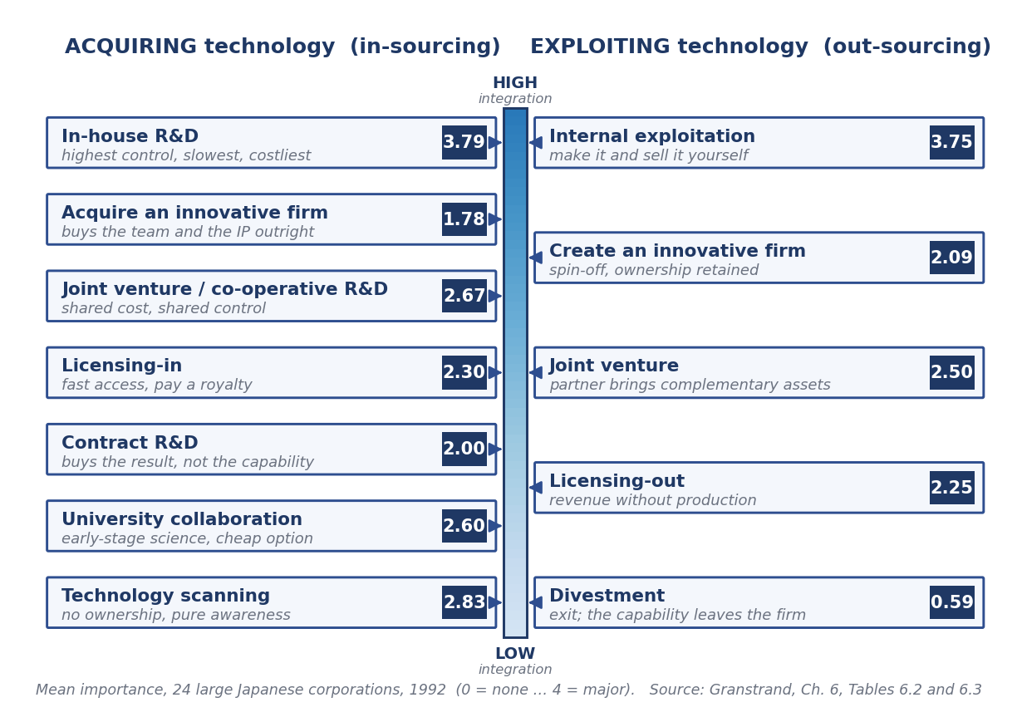
Figure 2 — The integration ladder. Every option is a trade of control against speed and cost.

3.1 The integration ladder
Read the figure as a single spectrum. At the top, the firm does everything itself and owns everything — maximum control, maximum cost, minimum speed. At the bottom, the firm owns nothing and merely observes, or sells the asset outright. Every intermediate rung is a quasi-integrated arrangement that trades some control for some speed or some cash.
The survey's headline finding is that in-house R&D dominates acquisition (3.79 out of 4) and internal exploitation dominates commercialization (3.75), and neither grew much between 1987 and 1992 — but the intermediate, quasi-integrated options grew steadily in importance. External technology sourcing was becoming more important without displacing internal capability. The two are complements, not substitutes: you need in-house competence to recognise, absorb and improve external technology at all.

3.2 Seven ways to acquire technology
- In-house R&D — the firm invents it. Highest control and the only route that builds durable internal competence, but the slowest and most expensive. Score 3.79.
- Acquisition of innovative companies or business units — buying the team and its IP outright. Fast and complete, but expensive and prone to cultural failure. Score 1.78, the lowest of the acquisition routes in this sample, though growing fastest (ratio 1.38).
- Joint ventures and other co-operative R&D, including with subcontractors — shared cost and shared risk, at the price of shared control and a negotiation over who owns the foreground IP. Score 2.67.
- Purchasing licences (licensing-in) — immediate access to proven technology in exchange for a royalty. The route Japan used extensively during its catch-up decades. Score 2.30.
- Other technology purchasing, such as contract R&D — buys a specified result, but not the underlying capability. Score 2.00.
- University collaboration — cheap access to early-stage science and to people. Notably, the firms surveyed rated collaboration with U.S. universities (2.95) above collaboration with their own domestic universities (2.70), and second only to in-house R&D. Overall score 2.60.
- Technology scanning, monitoring and intelligence — no ownership at all, simply structured awareness of what is being published, patented and standardised. Score 2.83, remarkably high, and the foundation of everything else: you cannot license or design around what you have not noticed.

3.3 Five ways to exploit it
- Internal exploitation — make the product and sell it yourself. Overwhelmingly the dominant mode, at 3.75. The firm captures the whole margin but must own or rent every complementary asset.
- Creation of innovative firms — spin out a semi-autonomous venture under retained ownership. Useful precisely when the new technology would be strangled inside an operating division committed to the incumbent technology. Score 2.09.
- Joint ventures — pair your technology with a partner's manufacturing or market access. Score 2.50, growing (ratio 1.37).
- Technology selling — chiefly licensing-out, but also selling contract R&D and engineering services. Revenue without the burden of production. Score 2.25, and the fastest-growing exploitation mode in the sample (ratio 1.46, and 1.90 in mechanical firms).
- Divestment — sell the asset and exit. Score 0.59, firmly rejected across all sectors, because the capability leaves with the asset.

3.4 Complementary assets — the reason you cannot always go it alone
Teece's framework explains the choice between these rungs better than any other. A technology by itself is rarely sufficient; it must be combined with complementary assets — manufacturing capacity, distribution, service networks, regulatory approvals, brand — before a customer will pay. The strategic question is who controls those assets and how easily they can be obtained.
If the complementary assets are generic and available to anyone, the innovator can go it alone and keep the margin. If they are specialised and controlled by someone else, the innovator faces a choice: build them (slow and expensive), or contract for them (fast, but the partner will extract much of the value). This is why strong patents matter more when complementary assets are hard to get: the patent is what stops the partner from simply taking the technology once they have seen it. It also explains why many brilliant inventions earn nothing for their inventors while the firm with the factory and the sales force earns a great deal.

3.5 The leakage problem
Two of Granstrand's findings are usually skipped over and should not be. First, a significant and growing amount of a company's technology is never commercialized within any reasonable time (score 2.14, rising). Second, there is a significant and growing amount of loss and leakage of proprietary technology (score 2.42, rising). Both are of roughly the same order of magnitude as deliberate technology selling.
Uncommercialized technology has innocent explanations — a lag before the market is ready, serendipitous results outside the firm's scope, exploratory work, a shift in strategy — and guilty ones, chiefly that nobody was made responsible for finding a route to market. Leakage happens through departing employees, suppliers, contract manufacturers and reverse engineering. The managerial response to the first is a systematic IP audit with an explicit 'use it, license it, or abandon it' decision on every asset; the response to the second is trade-secret hygiene, exit interviews, and contractual control over process suppliers.
PART 4

Four ways to turn technology into profit
Strip away the vocabulary and there are only four mechanisms by which a new technology makes money. They are used together, with the emphasis shifting as a product matures, and all four aim at the same economic end — reducing competitive pressure on the innovator long enough to earn a return.
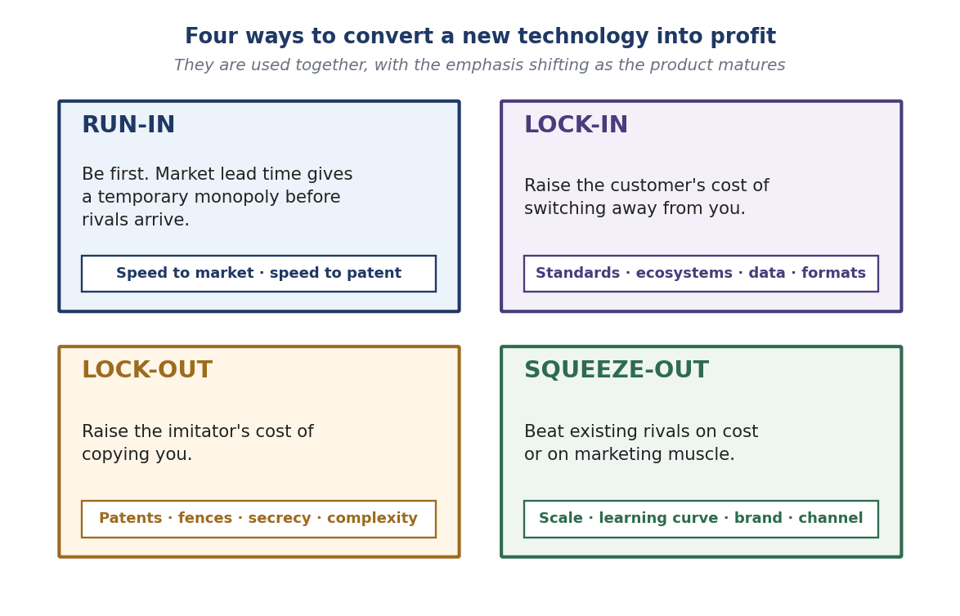
Figure 3 — The four mechanisms. Patents serve the third; they are not the only instrument.

4.1 Run-in, lock-in, lock-out, squeeze-out
Run-in means being first. Market lead time is itself a monopoly: for as long as no one else has a competing product, the innovator sets the price. This is why speed to market is a commercial weapon and not merely an operational virtue.
Lock-in raises the customer's cost of switching to someone else — through proprietary formats, ecosystems, accumulated data, training, or integration depth. Note the survey result: firms rated creating switching costs lowest of the six means (1.9 in Japan, 1.7 in Sweden). Locking competitors out was consistently seen as more effective than locking customers in.
Lock-out raises the imitator's cost of copying. This is where patents do their work, alongside secrecy, deliberately complex designs, and control of scarce inputs. It is the mechanism the whole IP system exists to serve.
Squeeze-out removes existing competitors by superior production cost or superior marketing — driving down the learning curve, out-spending on distribution, or simply out-branding. (The course material notes that squeeze-out also has a disreputable tail of non-conventional and illegal methods; those are outside the scope of legitimate strategy.)

4.2 What firms actually rely on — the evidence
Granstrand's survey asked directly how important each mechanism is for commercializing new product technologies, and compared Japan against Sweden and against U.S. data from Levin et al. (1987). The differences are striking and remain one of the most quoted results in the field.

Means of commercializing new product technology | Japan | Sweden | USA
Taking out patents to deter imitators (or collect royalties) | 3.3 | 1.9 | 2.0
Exercising secrecy | 2.4 | 2.0 | 1.7
Creating market lead times | 2.7 | 2.4 | 2.9
Creating production cost reductions | 2.9 | 2.7 | 2.7
Creating superior marketing | 2.7 | 3.0 | 3.1
Creating switching costs at the user end | 1.9 | 1.7 | n.a.

Read the first row carefully. Patenting ranked highest of all six means in Japan and near the bottom in both Sweden and the United States. Superior marketing ranked highest in the two Western samples. This is the single largest country difference in the dataset, and it challenges the common assumption that patents play a secondary role behind production and marketing. That assumption is simply not true for Japan.
A sector breakdown sharpens it further. Patenting ranked highest for both products and processes in chemical and electrical firms, with secrecy near the bottom — overturning a second common assumption, that secrecy dominates in process protection. Only mechanical firms fit the conventional picture, emphasising production cost reduction and process secrecy.
When the same firms were asked instead how effective each means is at preventing copying, patents came out on top and rising: patents 3.58, secrecy 2.42, lead-time advantage 2.00, and design complexity 1.65. Complexity, often assumed to be a natural barrier, was rated the weakest of the four.
Why the role of secrecy is shrinking
Improvements in analytical technique have made reverse engineering cheaper. Modern chemical analysis can detect minute traces in a product and infer the process that made it.
This cuts both ways, and the second cut is the one people forget. The innovator's secrecy barrier is more easily penetrated by imitators — and the imitator's secrecy barrier is more easily penetrated by the patent holder, who can now detect infringement by reverse-engineering a competitor's product.
Both effects push in the same direction: as reverse engineering gets cheaper, the propensity to patent rises. Outsourcing process equipment and engineering services to leaky suppliers has the same effect.

4.3 The limits of patents
A patent is not a wall. Asked what limits patents as protection, firms in every sector gave the same first answer: competitors can legally circumvent patent rights or invent around them (2.58) — the highest-rated limitation in the whole table. Next came the irrelevance of patents in fast-moving technology (1.96), the need to engage in cross-licensing with competitors (2.04), doubts about validity if contested (1.75), and excessive disclosure (1.71). Compulsory licensing was rated the least significant concern (1.00).

Limitation of patents as protection | Chemical | Electrical | Mechanical | Total
Competitors can legally invent around the patent | 2.44 | 2.80 | 2.40 | 2.58
Firms engage in cross-licensing with competitors | 2.00 | 2.56 | 1.20 | 2.04
Technological development is so rapid patents become irrelevant | 1.78 | 2.00 | 2.20 | 1.96
Patents are probably not valid if contested | 2.11 | 1.80 | 1.00 | 1.75
Proceedings require disclosing too much information | 1.78 | 2.00 | 1.00 | 1.71
New processes are not patentable | 1.88 | 1.60 | 0.80 | 1.52
New products are not patentable | 1.89 | 1.20 | 0.80 | 1.38
Firms do not try to enforce their patent rights | 1.11 | 1.00 | 1.40 | 1.13
Compulsory licensing can be imposed | 1.22 | 1.20 | 0.20 | 1.00

The strategic consequence is direct and is the bridge to Part 7. If the main weakness of a patent is invent-around, then claim scope is the critical variable, and the response is to file not one patent but a structure of them — blanketing the area and fencing the alternatives so that the routes around the invention are themselves occupied. Japanese corporations became known for exactly this.
It is also worth noting what limits profit from innovation in general, as distinct from what limits patents. Here the biggest constraints were high cost or limited access to the technology needed (2.62) and difficulties in marketing (2.57), both ahead of the inability to prevent copying (2.48). Access to suppliers was the least limiting (1.80). Imitation is a serious problem, but it is not the biggest one. Firms fail to profit from innovation more often because they cannot get the technology or cannot sell the product.
PART 5

The funnel and the valley of death
Any realistic account of commercialization has to begin with how much of it fails. The classic measurement is Mansfield's, and its proportions have proved durable.
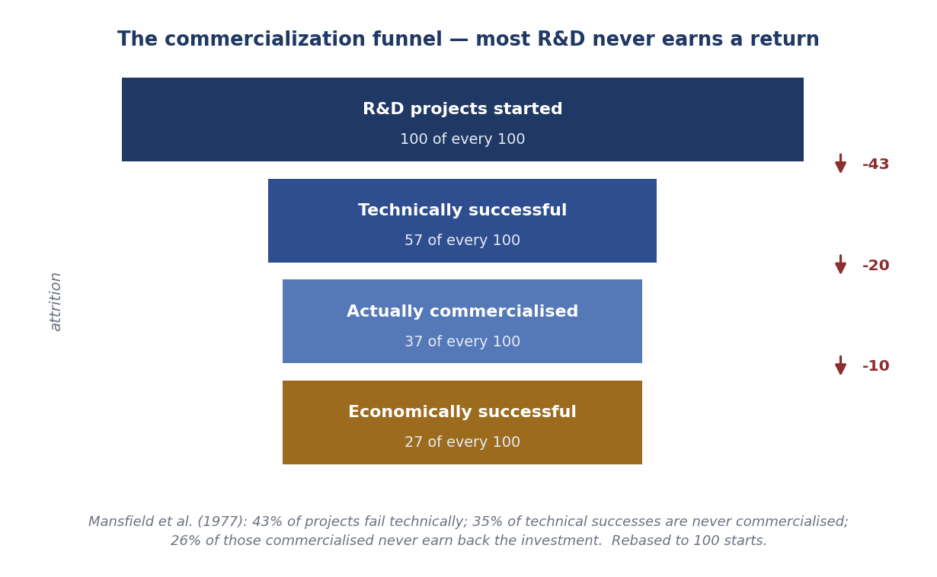
Figure 4 — Of every hundred R&D projects started, roughly twenty-seven ever earn back their cost.

Mansfield and colleagues found that 43 per cent of projects were not technically successful; of those that were, 35 per cent were never commercialized; and of those commercialized, 26 per cent were not economically successful. Compounding these leaves roughly twenty-seven of every hundred starts earning a genuine return. This is not a sign of incompetence. It is the normal arithmetic of research, and it is why portfolio thinking — not project thinking — is the correct managerial frame.
Two managerial conclusions follow. First, the attrition between 'technically successful' and 'commercialized' is the one you control. Technical failure is inherent in research; failing to commercialize a technical success is an organisational failure, usually of ownership, resourcing or market intelligence. Second, because returns are concentrated in a few winners, cutting the losers early is what funds the winners. A portfolio that is never pruned starves its own successes.

Where projects die: the valley of death
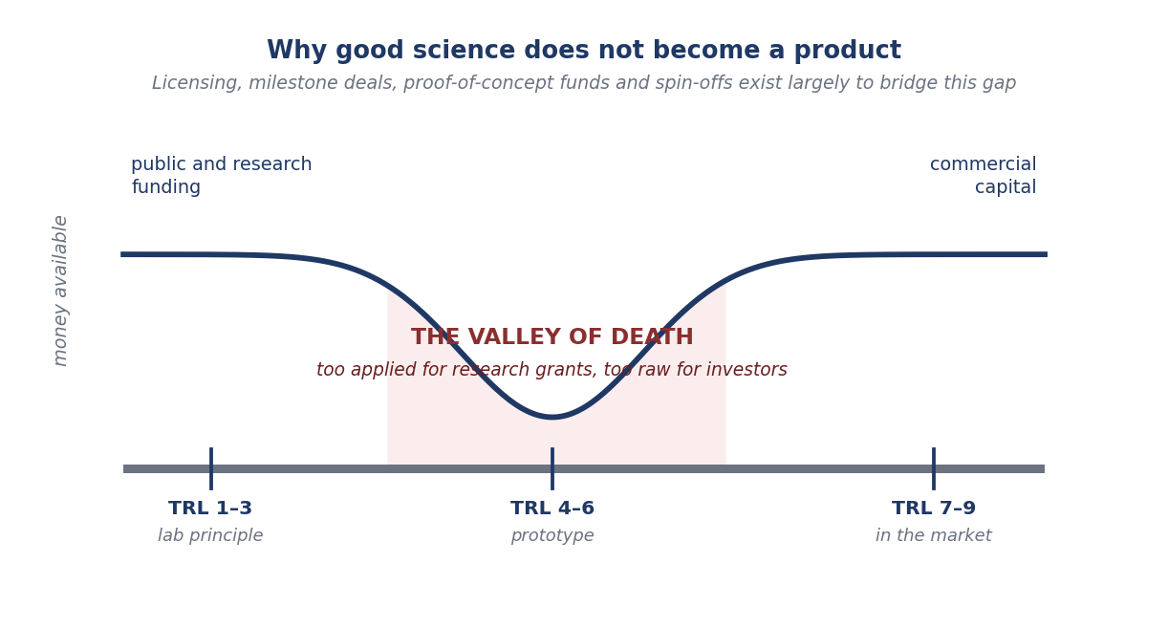
Figure 5 — The funding gap between proof of principle and market readiness.

Technology Readiness Levels (TRLs) run from 1, basic principles observed, to 9, proven in operation. Public and research funding is generally available at the low end, and commercial capital at the high end. In between — roughly TRL 4 to 6, where a prototype exists but no market has been demonstrated — sits the valley of death: too applied for research grants, too raw for investors.
A great deal of the machinery of IP commercialization exists to bridge this specific gap. Milestone-structured licences let a licensee pay in stages as risk falls. Proof-of-concept and translational funds pay for the prototype that unlocks private money. Spin-offs and university incubators create a vehicle that can raise equity where a research group cannot. Options and evaluation licences let a company hold a position cheaply while the technology matures. Understanding the valley explains why deal structures in this field look the way they do.
PART 6

The commercialization process, step by step
Whether the setting is a corporate R&D division or a university technology transfer office, the pipeline has the same eight stages. What differs is who makes the decision and what counts as success.

6.1 The eight-stage pipeline
- Invention disclosure. The inventor formally notifies the organisation, in writing, of what has been created. This is the trigger for every later step, and the stage most often mishandled — a public disclosure, conference paper or sales demonstration made before this step can destroy novelty and with it the patent. In Germany the equivalent duty is statutory (the Meldepflicht, Part 11).
- Evaluation. Three questions in parallel: is it patentable (novel, inventive, industrially applicable, and not excluded subject matter); is there a market; and do we have freedom to operate. A negative answer to any one can end the process here, which is the cheapest place to end it.
- Protection decision. Patent, trade secret, or publish defensively to stop anyone else patenting it. This is a genuine strategic choice, examined in Part 14.1.
- Marketing the technology. Identifying and approaching firms for whom this solves a real problem. Universities publish non-confidential summaries; corporations use brokers, industry contacts and licensing executives. Passive listing rarely works.
- Licensee identification and selection. The best licensee is not always the highest bidder — it is the one with the complementary assets and the genuine intention to develop. A licence to a firm that shelves the technology is worse than no licence.
- Negotiation. Valuation, structure and terms, covered in Part 8.
- Agreement and execution. Signature is the beginning, not the end. Diligence obligations, milestones and reporting have to be monitored, and audit rights exercised.
- Commercialization and revenue distribution. Income is shared according to policy — typically among the inventors, their department, and the institution. Transparent and generous inventor shares are the single most effective way to keep disclosures coming.

6.2 Freedom to operate, due diligence and the IP audit
Freedom to operate asks a different question from patentability. Patentability asks whether your invention is new; FTO asks whether selling your product would infringe someone else's live, in-force claim. The two answers are independent: you can hold a perfectly valid patent on an improvement and still be unable to sell it because it falls inside a broader earlier patent. An FTO search looks at unexpired claims in the countries where you intend to make, sell, use or import, and it should be run before committing to a launch, not after.
Patent landscaping maps a technology field — who is filing, in what sub-areas, at what rate — and is a cheap way to find white space, spot an emerging competitor, or identify a licensing target. Due diligence verifies, before a deal, that the seller actually owns what it claims to own, that inventorship and assignments are clean, that maintenance fees are paid, and that no encumbrances or prior licences exist.
An IP audit is the periodic inventory of everything the organisation owns, matched against the products and programmes that use it. The output is a decision on each asset: maintain, license out, or abandon. Because maintenance fees escalate over a patent's life (in the United States they fall due at 3.5, 7.5 and 11.5 years), an unpruned portfolio quietly consumes the budget that should be funding new filings. Pruning is not a failure; it is the discipline that makes the portfolio affordable.
PART 7

Patent strategy: sequence, claims and portfolio

7.1 The filing sequence
The filing sequence is best understood as a series of purchased options. At each stage you pay a small amount to keep a larger decision open, and the art is in deferring the expensive commitment until you know enough to make it.
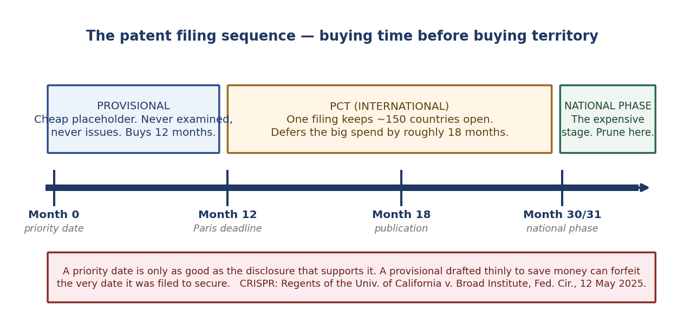
Figure 6 — Each stage buys time; only the last stage buys territory.

The provisional application establishes a priority date at modest cost. It is never examined and never issues as a patent. It gives twelve months in which to convert — a period fixed by the Paris Convention's twelve-month priority right. Its value is entirely in what it discloses: under 35 U.S.C. § 112 the written description must support whatever is later claimed.
The PCT application preserves the option of entering the national phase in most jurisdictions through a single international filing, and defers the large territorial cost decision by roughly eighteen further months — national phase entry falls at thirty or thirty-one months from priority. For a university or a start-up this is the crucial instrument, because it buys time to find a licensee before committing to territory.
The national phase is the expensive stage: translations, local agents, and a lifetime of maintenance fees in every country. Territory should follow the licensee's actual market, not a wish list. Unlicensed families are pruned here.
The cautionary case — CRISPR
In the CRISPR-Cas9 interference, Regents of the University of California v. Broad Institute (U.S. Court of Appeals for the Federal Circuit, 12 May 2025, Nos. 22-1594 and 22-1653), the Federal Circuit affirmed the Patent Trial and Appeal Board's finding that UC's earliest provisional applications lacked adequate written description for a single-guide CRISPR-Cas9 system working in eukaryotic cells.
The lesson: a priority date is only as good as the disclosure that supports it. A provisional drafted thinly to save money can forfeit the very date it was filed to secure.
Status, accurately stated: the court simultaneously vacated and remanded on the question of conception, holding that the Board had wrongly conflated conception with reduction to practice. The interference is therefore not finally resolved — priority and ownership remain open.

7.2 Claim architecture
A patent's protection is defined entirely by its claims. An independent claim stands alone and defines the broadest scope; a dependent claim refers back to an independent claim and adds a further limitation, narrowing it. Dependent claims are not decoration — they are the fall-back positions that survive when the broad claim is invalidated by prior art.
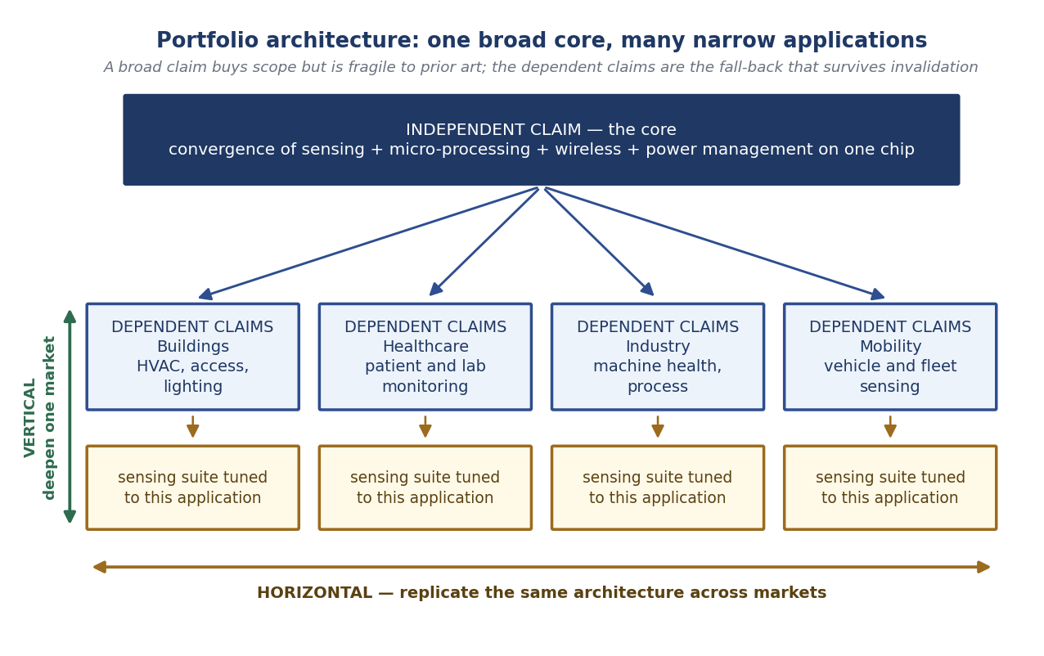
Figure 7 — One broad core claim, with dependent claims mapping the applications and markets.

The course use case shows the architecture clearly. A micro-system-on-a-chip converged four functionalities — a multiple sensing suite, a micro-processor, wireless communication and efficient power management — within a single silicon layer. The strategy was to draft one powerful, broad, independent claim on the overall concept and on that convergence, and then to add dependent claims covering specific applications for specific markets, since the applications vary from market to market while the core does not.
The portfolio then expands along two axes. Vertically, within a single market such as building automation, by adding claims to the particular sensing suites and configurations that market needs. Horizontally, across different markets — healthcare, industrial, mobility — by replicating the same architecture with different application claims. The core claim is kept throughout; it is the trunk from which everything else branches.
The unavoidable tension is between breadth and validity. A broad claim covers more but is more vulnerable: the wider the net, the more prior art it catches. This is why serious portfolios contain a graded series of claims of decreasing scope, and why continuation and divisional applications matter — the former pursues further claims from the same disclosure, the latter carves out a distinct invention identified by a restriction requirement. Together they let a single original disclosure generate a family of patents over many years.

7.3 Blanketing, fencing and pruning
Because invent-around is the principal weakness of any single patent, the portfolio-level answer is to occupy the alternatives. Blanketing files densely across an area of technology so that a competitor cannot move without encountering a claim. Fencing specifically patents the plausible design-around routes — the alternative chemistries, geometries or protocols that a rival would turn to — so that the fence stands even where the core claim does not reach. A patent thicket is the aggregate effect: an area so densely claimed that entry requires a licence from someone.
These strategies work, and they are expensive. They are justified where the product has a long life, a large market, and a known set of substitutes. They are not justified for a speculative technology with an uncertain market, which is exactly why the IP audit and disciplined pruning are the necessary counterweight. A portfolio should be built like a fence where it matters and mown like a lawn everywhere else.
PART 8

Licensing
Licensing is the most common route to generating IP value, and the most complex to negotiate. A licence is permission — the owner retains title and grants defined rights to someone else. That distinguishes it from an assignment, which transfers ownership outright.

8.1 Types of licence

Type | What it grants | When it is used
Exclusive | Only the licensee may practise the IP — the licensor excludes even itself. | When the licensee must invest heavily and needs certainty; standard for pharmaceutical and university deals.
Sole | The licensee and the licensor, but no one else. | When the licensor wants to keep making the product but needs a partner for reach.
Non-exclusive | Many licensees may practise the same IP. | Platform technologies, research tools, standards; maximises diffusion and total royalties.
Field-of-use | Rights limited to a defined application. | Lets one technology be licensed to several firms without them competing — building automation to one, medical to another.
Territorial | Rights limited to defined countries. | Matches licensee capability to geography; keeps other markets available.

8.2 The terms that decide the money
A licence is a package, and negotiating only the royalty rate is a beginner's error. The terms that matter are the upfront fee (paid on signature, compensating past investment and demonstrating commitment); milestone payments (triggered by defined technical, regulatory or sales events, which shift risk sensibly toward the future); the running royalty (rate and base — see 8.5); minimum annual royalties (which prevent a licensee from parking the technology unused); sublicensing rights and the share of sublicence income; the treatment of improvements made by either side; diligence obligations requiring the licensee actually to develop the product; audit rights; and termination provisions, including what happens to the licensee's own improvements when the licence ends.

8.3 The negotiation
The course material describes an approach that works in practice: the seller states an expectation that becomes the upper limit of the IP's value, supported by good reasons; the buyer then states an offer that becomes the lower limit, with clear justification. The zone between them is where agreement is possible.
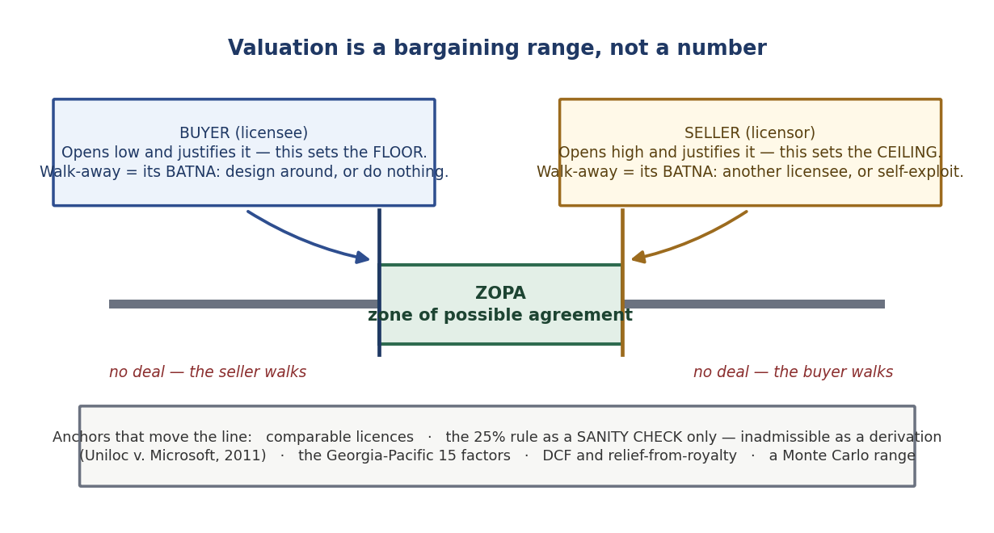
Figure 8 — The bargaining range. Each side's walk-away point is set by its alternatives, not by the technology.

In negotiation language this range is the ZOPA — the zone of possible agreement. Its boundaries are set by each side's BATNA, the best alternative to a negotiated agreement. The licensee's BATNA is to design around, to license a competing technology, or to do nothing; the licensor's is another licensee, or exploiting the technology itself. Improving your BATNA is more effective than improving your arguments. A licensor with three interested parties is in a different negotiation from one with a single suitor, regardless of what the technology is worth.
It is best practice, on both sides, to field a team rather than an individual: business people who understand the market, lawyers who understand the risk allocation, and the engineers and inventors who understand what the technology can actually do. Value is routinely destroyed by lawyers negotiating technical scope they do not understand and by engineers conceding commercial terms they have not modelled.
The course material adds a comparative note: in the United States the process of licensing in the corporate world is not very different from the academic world so far as value assessment goes, though compliance and government regulation change the process. In the European Union, academic and corporate licensing practice and expectations differ considerably.

8.4 The licensing-revenue rule of thumb
There is no magic formula and every situation differs, but where IP is associated with a product a serviceable rule of thumb exists:

ALR ($) = LR (%) × AAFC ($), where L-limit < LR < H-limit
ALR is annual licensing revenue. LR is the negotiated percentage. AAFC is the annual cost of products after the factory.
L-limit, the lower bound of LR, typically varies between 1 and 3 per cent. H-limit, the upper bound, typically varies between 3 and 7 per cent.

The interesting choice here is the base. AAFC — cost of products after the factory — is used precisely because it is easy to track and to audit. It deliberately excludes shipment cost and profit margin, because both are variable and both invite dispute. A royalty base you cannot verify is a royalty you will not collect; a base the licensee can manipulate is worse still. Auditability is a design criterion, not an afterthought.

8.5 Royalty base, royalty rate and stacking
Every running royalty is a rate applied to a base, and arguments about the base are usually worth more money than arguments about the rate. Where a patented component sits inside a large product, the licensee will argue for the smallest saleable patent-practising unit (SSPPU) — the royalty should apply to the chip, not the car. The licensor will invoke the entire market value rule (EMVR), which permits the whole product price as the base, but only where the patented feature is what drives consumer demand for that product. The rule is demanding and courts apply it narrowly.
Royalty stacking is the cumulative problem: when a single product reads on patents held by twenty different owners, each demanding three per cent, the total royalty burden can exceed the product's margin. This is the economic driver behind patent pools and portfolio licensing (Part 9), which exist to make the total burden predictable and the transaction costs bearable.
PART 9

Cross-licensing, pools and standards

9.1 From deadlock to mutual access
The classic situation runs as follows. Company A obtains U.S. Patent X. Company B sues A for infringing its Product V. Litigation continues for more than three years with no resolution. In the course of it, both sides discover something more useful than a judgment: X can enhance V, and B's patent U can benefit A's product Y. A and B therefore cross-license — X for V and U for Y.
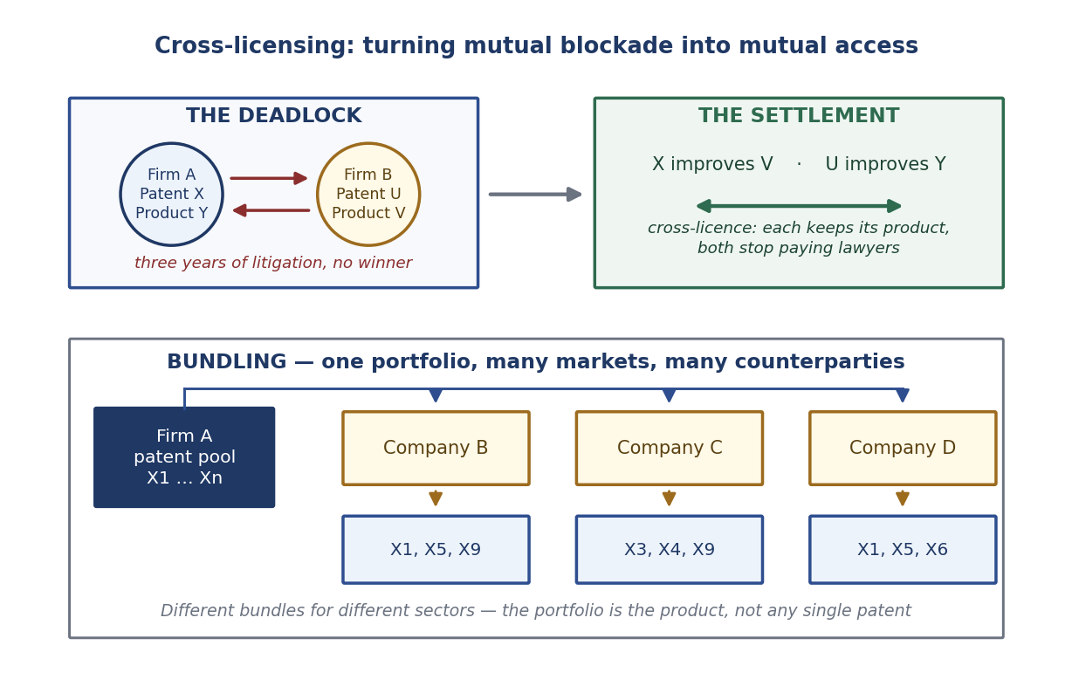
Figure 9 — Cross-licensing converts a mutual blockade into mutual access; bundling scales the same logic across markets.

Cross-licensing is the rational settlement of a mutual blockade. When two firms in the same field each hold patents the other needs, litigation is a negative-sum game: both pay lawyers, neither ships. The cross-licence restores freedom to operate on both sides. This is also why firms build defensive portfolios in the first place — a patent you never assert still has value as a bargaining chip, an arrangement sometimes described as mutually assured destruction. The survey data in Part 4 support this: firms rated 'we engage in cross-licensing with competitors' at 2.04 as a limitation of patents, highest in electrical firms at 2.56, where portfolios overlap most.

9.2 Bundling and portfolio licensing
The logic scales. Rather than negotiating patent by patent, a firm with a large portfolio bundles different subsets for different counterparties according to the markets each serves — patents X1, X5 and X9 to Company B; X3, X4 and X9 to Company C; X1, X5 and X6 to Company D. The same patent can appear in several bundles.
Bundling reduces transaction costs enormously and gives the licensee certainty that it is clear of the whole portfolio rather than of one patent. The portfolio, not the individual patent, becomes the product. A patent pool extends this across owners: several firms place their essential patents into a single pool offering one-stop licensing — MPEG LA, Avanci for automotive cellular, and Via LA are the familiar examples.
There are limits. Because these arrangements involve competitors agreeing on terms, they attract antitrust scrutiny — in the United States under the DOJ/FTC Antitrust Guidelines for the Licensing of Intellectual Property, and in the European Union under the Technology Transfer Block Exemption Regulation and its guidelines. Tie-outs, price-fixing through a pool, and over-broad grant-back clauses that hand the licensor all of the licensee's future improvements are the standard danger areas.

9.3 Standards, SEPs and FRAND
As products become interdependent and compatibility itself becomes valuable to consumers, technical standards become central to commercialization. Standards and IP, however, pull in opposite directions: a standard's purpose is that everyone can implement it, while a patent's purpose is that not everyone can.
Standards are set in two ways. De facto standards emerge from the market after the fact, through dominance — 'volume begets standards'. To win one, a firm needs rapid buyer diffusion (helped by penetration pricing) and, at least as importantly, rapid seller diffusion, which means licensing generously or opening the technology. Alternatively it can refuse to license and try to make its proprietary solution dominant by itself. De jure or consensus standards are agreed in advance through formal bodies.
A patent that blocks a proposed or actual standard — a standard-blocking patent — can be worth an enormous amount, particularly for a global standard. It can also kill the standard: if the holder's licensing policy is ungenerous, implementers will route around it or abandon the standard entirely. Standards bodies therefore require members to declare standard-essential patents (SEPs) and to commit to license them on fair, reasonable and non-discriminatory (FRAND) terms. What counts as FRAND is litigated continuously and is among the most active areas of IP law today.

9.4 Two cases: VHS and GSM
VHS versus Betamax. The format battle for video cassette recorders began in 1975. JVC's comparatively generous licensing policy for VHS spread the format among manufacturers rapidly, and VHS won decisively by the mid-to-late 1980s — inflicting on Sony what the course material describes as the largest business and morale loss in its history. The lesson is counter-intuitive and important: in a standards race, licensing your technology away can be the way to win with it. Diffusion beat exclusivity.
GSM. In the early 1990s the European GSM system involved over 2,000 patents, of which about thirty were standard-blocking. The telecom industry had a club culture: national service providers were monopolies, patents were treated as a secondary issue, and there was effectively a gentleman's agreement to be generous with each other. Blocking a standard with a patent was considered, in the course material's phrase, close to mutiny.
That changed in the late 1980s when Motorola, a newcomer to the European scene, began to use its patents assertively. European manufacturers found that they might have to pay royalties for inventions they believed they had originated, that Motorola could block the standard, and that it could offer a European licence while retaining a strong position everywhere else the standard was later adopted. Motorola acquired the image of the 'bad guy'; Motorola's answer was that it came from an electronics industry where patenting was simply part of doing business, and that the GSM group had recognised the IPR issues far too late.
The episode changed an entire industry's culture. It triggered a permanent rise in IPR awareness in telecommunications and a new pattern of patenting and competitive behaviour, reinforced by privatisation, liberalisation and globalisation. In particular it triggered a turnaround in Ericsson's approach to IP. Three reasons explain why patents became central to standard-setting in telecom from the 1980s: fragile collective agreements were challenged by assertive patent holders who recognised the commercial potential; standards became linked to newer, patentable sub-technologies; and the consumer electronics industry, with its more combative practices, moved into telecom.

9.5 Huawei: the modern template
Huawei is the clearest contemporary illustration of licensing and cross-licensing run as a deliberate corporate programme. Its published position is that respecting and protecting IP is the foundation of innovation, and that while promoting its own growth it also licenses to other industry players. Over the past twenty years it has conducted extensive cross-licensing negotiations with key ICT patent holders and has entered into more than 260 patent licence agreements with major global ICT companies across Europe, the United States, Japan and South Korea.

Metric | Figure | Note
Cumulative R&D investment | CNY 1.38 trillion | Over the last decade
R&D spending in 2025 | CNY 192.3 billion | 21.8% of total revenue
Standards contributions in 2025 | 7,000+ | Connectivity, computing, smart devices, IAS and other domains
Active patents held | 165,000+ | As at the end of 2025
Patent licence agreements | 260+ | Europe, USA, Japan, South Korea
Fortune Global 500 licensees | 55 | Paying royalties to Huawei

For comparison, Huawei's 2024 annual report gave R&D of CNY 179.7 billion (20.8 per cent of revenue), cumulative R&D above CNY 1.249 trillion, and more than 150,000 active patents; the company disclosed roughly US$630 million in patent licensing revenue for 2024. Note that the figures in the course slides are the 2025 numbers from Huawei's IP page, and should be labelled as such.
Huawei also illustrates FRAND practice concretely. On 16 March 2021 it announced royalty caps for its cellular SEPs: a reasonable percentage of the handset selling price with a per-unit cap of US$2.50 for multi-mode 5G smartphones, US$1.50 for 4G, and US$0.50 for Wi-Fi 6. Publishing a cap is itself a commercialization strategy — it reduces the transaction cost of every negotiation, makes the portfolio predictable to implementers, and positions the company as a reasonable licensor in future FRAND disputes.
PART 10

Valuation
Valuation is where most IP negotiations founder, because the buyer wants to minimise the number and the seller to maximise it, and because — unlike a building or a bond — there is rarely a directly comparable asset.

10.1 Three families of method
The cost approach asks what it would cost to reproduce or replace the asset — the R&D spent, or what a competitor would have to spend to get there. It sets a floor in some negotiations but is economically weak: what something cost to create says nothing about what it is worth. A failed technology can be very expensive.
The market approach looks at comparable transactions — royalty rates in similar licences, in similar fields, at similar stages. It is the most persuasive evidence when it exists, and it frequently does not, because licence terms are usually confidential and genuinely comparable technologies are rare.
The income approach projects the cash flows the IP will generate and discounts them to present value. Its main variants are discounted cash flow (DCF) and relief-from-royalty, which asks what you would have had to pay to license the asset had you not owned it. For early-stage university technology the discount rates are necessarily high — commonly 25 to 40 per cent or more — reflecting technical, regulatory and market risk. Option-based valuation (Black-Scholes or binomial models) is the sophisticated cousin, appropriate where staged investment means the right to proceed is itself valuable.

10.2 The 25% rule and why courts rejected it
The best-known heuristic, associated with Robert Goldscheider, allocates roughly a quarter of the licensee's expected operating profit on the product to the licensor. It is attractive because it is quick, easy to communicate, and produces a plausible opening number. It is criticised because it ignores the IP's relative contribution to the finished product — a patented component in a complex device does not necessarily deserve a quarter of the profit of the whole.
The legal position, stated precisely
In *Uniloc USA, Inc. v. Microsoft Corp. (U.S. Court of Appeals for the Federal Circuit, 4 January 2011), the court held the 25% rule of thumb to be a fundamentally flawed tool and inadmissible* as evidence for determining a reasonable royalty.
Crucially, the court also held that adjusting the rule with the Georgia-Pacific factors cannot cure the underlying defect, and separately rejected the misuse of the entire market value rule as a 'check' on the result.
Practical consequence: use the 25% rule as a private sanity check on a rate you have derived some other way. Never present it as the derivation itself.

10.3 Georgia-Pacific, Monte Carlo, and the structural point
The surviving framework for a reasonable royalty is the fifteen Georgia-Pacific factors (Georgia-Pacific Corp. v. U.S. Plywood Corp., 1970), which direct attention to established royalties for the patent, rates paid for comparable patents, the nature and scope of the licence, the commercial relationship between the parties, the patent's advantages over old modes, the portion of profit attributable to the invention, and the outcome of a hypothetical negotiation between a willing licensor and licensee.
Monte Carlo and scenario analysis replace single-point forecasts with distributions over adoption, price and time to market. They suit staged technical and regulatory risk, where failure is probabilistic rather than binary, and their output is a range with a confidence level. That is more honest than a single number and considerably harder to negotiate against. The standing warning applies: the output is only as good as the priors, and precision is not accuracy — a simulation reported to two decimal places is still a guess if its inputs were guesses.
The structural point — learn this one
Valuation of university or early-stage IP is rarely the valuation of an asset in isolation. What is actually being priced is a bundle: the patent family, the inventor's continued involvement, the institution's willingness to accept milestones instead of cash, and the licensee's cost of capital.
Deal structure and valuation are the same conversation. A licensor who cannot move on headline value can often close the gap by restructuring — lower upfront in exchange for higher milestones, a narrower field of use, a shorter exclusivity period, or equity instead of cash.
PART 11

Who owns the invention?
Everything in this subject assumes somebody owns the IP. Who that is depends on the jurisdiction, and the differences are larger than most students expect. This is also the section that most reliably appears in examinations, because it rewards precise knowledge.

The United States — ownership by contract
Patent rights vest initially in the human inventor; 35 U.S.C. § 115 requires each inventor's oath or declaration. Employers acquire rights through pre-invention assignment agreements in the employment contract. The drafting detail is decisive: a present-tense 'hereby assigns' operates as an immediate transfer, whereas 'agrees to assign' is only a promise to do something later, which can be defeated by an intervening assignment.
This is exactly what happened in *Board of Trustees of the Leland Stanford Junior University v. Roche Molecular Systems, 563 U.S. 776 (2011). The Supreme Court held, 7–2 (Chief Justice Roberts writing), that the Bayh-Dole Act does not automatically vest title in the university* — title passes only by a valid assignment from the inventor. Stanford lost standing because its researcher had earlier signed a present-tense assignment to Cetus, Roche's predecessor, while his agreement with Stanford was only a promise to assign.
Two further doctrines matter. The shop-right doctrine gives an employer a non-exclusive, royalty-free, non-transferable licence to use an invention that an employee made using the employer's time, materials or facilities, even without any assignment. And state law limits how far assignment clauses can reach: California Labor Code § 2870 voids the assignment of inventions an employee developed entirely on their own time, without employer equipment or trade secrets, and unrelated to the employer's business or anticipated research; § 2872 requires employers to notify employees of these limits.
On compensation, the course material's summary is accurate: inventors typically receive a modest honorarium, awards and recognition rather than a statutory share. The motivational theory is cultural — the company cultivates an open environment that treats failure as learning, and passion is expected to drive invention.

Germany — ownership by statute
Germany takes the opposite starting point. Under the Employee Inventions Act (Gesetz über Arbeitnehmererfindungen, ArbnErfG) the invention belongs initially to the inventor, and the statute then channels it to the employer through a defined procedure with a mandatory price attached.
- Duty to report (Meldepflicht, § 5).* The employee must report a service invention to the employer in text form without delay. Everything else runs from this.
- Deemed claiming (Inanspruchnahmefiktion, § 6(2)). Since 1 October 2009, a service invention is deemed claimed by the employer unless the employer expressly releases it in writing within four months* of a proper report. This reversed the pre-2009 position, under which silence meant the invention became free for the employee. Silence now favours the employer — but the duty to pay follows.
- Reasonable compensation (angemessene Vergütung, § 9). On claiming, rights transfer to the employer and the inventor acquires a statutory right to reasonable compensation. It is calculated under the Federal Ministry's Guidelines for Remuneration of Employee Inventions (Vergütungsrichtlinien), most often by the licence-analogy method*: the notional licence value of the invention, multiplied by a share factor reflecting the employee's contribution relative to the firm's.
- Release back to the inventor. If the employer releases the invention, or fails to file, or abandons the application, the rights revert to the inventor, who may then exploit them.
- Dispute resolution. The *Arbitration Board (Schiedsstelle) at the German Patent and Trade Mark Office (DPMA) mediates compensation disputes before they reach court. Section 42 contains special rules for university inventions, introduced when Germany abolished the 'professor's privilege' in 2002*.
The course material's characterisation is broadly right — inventors do negotiate assignment terms under government rules, and the invention can revert — though the mechanism is the statutory release and reversion described above rather than a general 'term limit'. The practical consequence it identifies is real: because compensation is a legal entitlement rather than a discretionary bonus, building the open, passion-driven culture that American firms rely on is genuinely harder.

The United Kingdom — ownership by employer, with a compensation safety valve
Under the Patents Act 1977, sections 39 to 43, an invention made in the normal course of an employee's duties belongs to the employer. Section 40 allows the employee to claim compensation where the patent has been of 'outstanding benefit' to the employer.
For decades this was regarded as unreachable, until *Shanks v Unilever plc [2019] UKSC 45. The Supreme Court awarded Professor Ian Shanks £2 million, roughly a 5 per cent 'fair share'* of the approximately £24 million benefit Unilever derived from his glucose-biosensor patents, uplifted for inflation. Critically, the Court rejected the 'too big to pay' argument — that a giant employer's inventions can never be outstanding relative to its overall turnover. Benefit must be assessed against the relevant part of the business, not the whole conglomerate.

Japan — statutory remuneration after a famous shock
Article 35 of the Japanese Patent Act governs employee inventions. Its modern form was shaped by the blue LED case. Shuji Nakamura, then at Nichia Corporation, invented the high-brightness blue LED; in January 2004 the Tokyo District Court awarded him ¥20 billion. On appeal the parties settled in January 2005 for ¥843 million — ¥608.57 million in remuneration plus ¥235.34 million in delay interest. Nakamura later shared the 2014 Nobel Prize in Physics. The case drove Japan's 2004 reform of Article 35, which requires that remuneration be reasonable and, importantly, that the procedure for setting it be fair — consultation with employees, disclosure of standards, and an opportunity to be heard.

India — ownership by contract, with no dedicated compensation statute
The Patents Act 1970 contains no dedicated employee-inventor compensation provision. Ownership is governed by the employment contract and assignment deeds, making careful drafting essential. Section 3 lists non-patentable subject matter, and section 3(d) — which blocks the patenting of new forms of known substances absent enhanced efficacy — is the provision most often examined, upheld by the Supreme Court in Novartis AG v. Union of India (2013).

Jurisdiction | Initial owner | How the employer gets it | Inventor's compensation
USA | The inventor | Pre-invention assignment; 'hereby assigns'. Shop right as a fallback. | Contractual — typically an honorarium and recognition. No statutory right.
Germany | The inventor | Deemed claimed after 4 months unless released (§ 6(2), since 2009). | Statutory right to reasonable compensation; licence-analogy method; DPMA arbitration.
UK | The employer | By operation of ss. 39–43 for inventions made in the course of duties. | Only for 'outstanding benefit' (s. 40). Shanks v Unilever: £2m.
Japan | Employer may take by rule | Article 35, as reformed in 2004. | Reasonable remuneration, with a fair procedure. Nakamura settled at ¥843m.
India | The inventor | Employment contract and assignment. | No dedicated statute; whatever the contract provides.
PART 12

Publicly funded research

12.1 The Bayh-Dole Act of 1980
Enacted as P.L. 96-517 and codified at 35 U.S.C. §§ 200–212, the Bayh-Dole Act was Congress's response to the poor commercialization record of federally funded technology. Before it there was no uniform patent policy across funding agencies, and the default rule vested ownership in the government itself. The result was an inventory of roughly 28,000 government-owned patents of which fewer than 5 per cent were licensed — the figure is anchored in the U.S. General Accounting Office report GAO/RCED-98-126 (1998).
The Act awards title to inventions made with federal support to the contractor, where that contractor is a small business, a university or another nonprofit institution. A subsequent presidential memorandum in 1983, reinforced by Executive Order 12591 (1987), extended the same policy to all federal government contractors, creating a uniform national rule. The contractor may therefore obtain and own a patent, and it is that exclusivity which supplies a private partner with the incentive to fund development.
The logic is worth stating explicitly because it is the answer to the obvious objection. If publicly funded research were simply placed in the public domain, no firm would invest the further millions needed to turn a laboratory result into an approved product, because a competitor could free-ride on that investment. Exclusivity is granted not to reward the university but to induce the private development spending that the public otherwise would not get.

12.2 March-in rights and the obligations that come with title
Title comes with conditions. The government retains a non-exclusive, royalty-free government-use licence. Section 204 imposes a U.S. manufacturing preference for products sold in the United States under an exclusive licence. Contractors must disclose inventions and elect title within set periods, and must report on utilisation.
Most significantly, section 203 creates march-in rights, allowing a funding agency to require the contractor to grant a licence to a responsible applicant in limited circumstances — chiefly a failure to take effective steps to achieve practical application, or a failure to satisfy health and safety needs. March-in rights have never once been exercised in the history of the Act.
The recent development to know: in December 2023 NIST published a draft Interagency Guidance Framework which proposed, for the first time, that price could be a factor in a march-in decision. It drew heavy opposition from industry and universities — an earlier 2021 proposed rule barring price-based march-in had been dropped from the 2023 final rule — and the December 2023 framework remains a draft. No price-based march-in has been adopted or exercised. Treat this as live policy, and check for developments.
The seminar question worth thinking about
Is Bayh-Dole's success best measured by licensing income, by products delivered, or by the counterfactual rate of non-commercialization it displaced?
Licensing income is easy to count and misleading — it is dominated by a handful of blockbuster drug patents. Products delivered is closer to the policy purpose. The counterfactual is the honest measure and is unobservable. A good answer argues that the Act should be judged against its stated aim (commercialization) rather than against revenue, while acknowledging that the measurable proxies all have severe selection problems.
Equivalents elsewhere: Japan's Article 19 of the Industrial Technology Enhancement Act; Germany's abolition of the professor's privilege in 2002; India's Protection and Utilisation of Public Funded Intellectual Property Bill, introduced in 2008 but never passed.

12.3 The system in aggregate
United States academic technology transfer is measurable, and the AUTM Licensing Activity Survey has benchmarked it annually for more than thirty years. The 2023 survey, covering 200 institutions, reported:

Indicator (AUTM 2023 U.S. Licensing Activity Survey) | Figure
Total U.S. academic research expenditure | $104 billion — the highest in the survey's 30-year history
Invention disclosures reported to institutions | More than 25,000 (over half a million cumulatively)
Patent licences executed | Nearly 3,000
Licence income reported | $3.6 billion — below the $3.8 billion peak recorded in 2022
New commercial products reaching the market | 714
Operational startups built on academic research | Approximately 7,000 (standing population)

The shape of these numbers is the lesson. Disclosures outnumber licences by roughly eight to one, and only a fraction of licensed technologies ever become products. $104 billion of research produced $3.6 billion of licence income — a ratio that makes clear that licence revenue is not, and was never intended to be, the primary return on public research funding. The primary returns are trained people, published knowledge and the 714 products. Figures are self-reported by participating institutions.

12.4 Public research organisations have different priorities
The process in the public research sector is not very different from the private and academic sectors, but the objective function is. Revenue maximisation is replaced by a mission, and the course material lists the priorities: accelerated market penetration; giving some priority to SMEs or promoting underserved regions; capacity development; national security; global competitiveness; providing resilience to national infrastructure; preventing nefarious actors from accessing technology and commercializing it with ill intentions; and creating harmonious relationships with the private sector.
These priorities have direct operational consequences. A mission-driven organisation may license non-exclusively and cheaply to maximise diffusion where a corporation would license exclusively and expensively to maximise revenue. It may favour a domestic SME over a better-resourced foreign bidder. And it operates inside a technology-protection regime — export controls such as ITAR and EAR, foreign-investment review through CFIUS, and research-security programmes — that a purely commercial licensor does not face. The institutional models vary: the U.S. Department of Energy national laboratories work largely through CRADAs (Cooperative Research and Development Agreements); Germany uses the Fraunhofer applied-research institutes; India has CSIR; Singapore has *ASTAR**.
PART 13

Diversification and the economies of scale, scope and speed
This part answers a question the earlier material raises but does not resolve: once you own a technology, how do you get the most out of it? Granstrand's answer, drawn from Japanese corporate practice, is the most useful framework in the literature.

13.1 The staircase
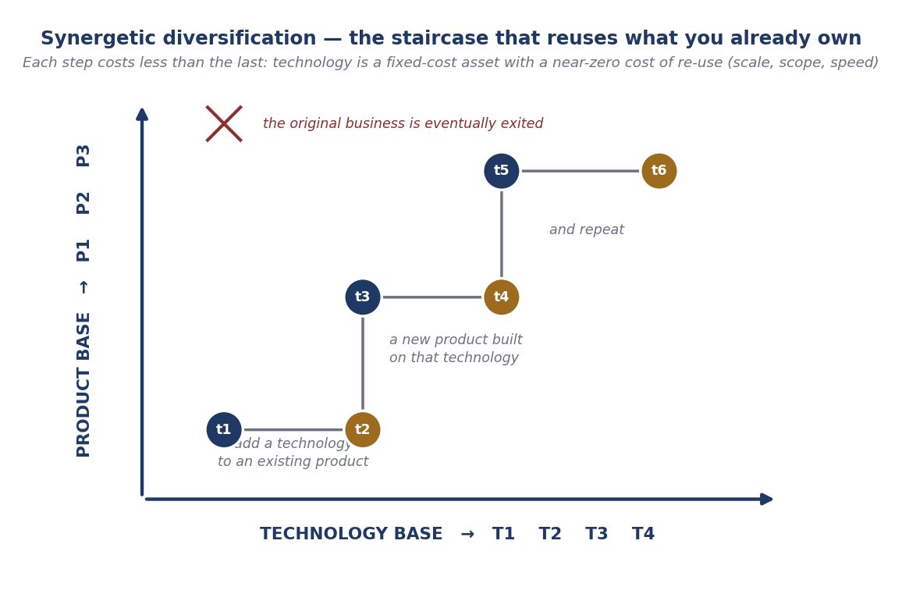
Figure 10 — Technology-related product diversification interacting with product-related technology diversification.

The process runs as an alternating staircase. The firm adds a new technology to an existing product, improving its performance-to-cost ratio or adding functionality. As in-house competence in that technology builds, the firm searches for new applications, which after some time may justify entering a new product area. That new product then attracts further technologies, and the cycle repeats. Over enough steps a company can leave its historical origins entirely.
The economics of this are the point. Technological economies of scale arise because technical competence is built at a considerable fixed cost but applied at low variable cost: the same technology can be used in several products, with an adaptation cost that is sometimes considerable but usually minor. As with any body of knowledge, the cost of technology is not very dependent on the scale of its use. This is what makes generic technologies so valuable by definition.
Technological economies of scope arise when new technologies are complementary to those already in a product's technology base, producing cross-fertilisation. There is a countervailing cost — integrating more technologies requires more coordination and communication, so R&D costs rise progressively as products become more multi-technological. Economies of speed arise because a diversified firm with a broad technology base can incorporate a needed technology not only more cheaply but faster, by transferring it internally rather than acquiring it afresh.
Two important qualifications. First, these are technological economies of scale, distinct from traditional economies of scale in physical production or from threshold effects in laboratory size — though those matter too. Second, internal transfer is not automatic: not-invented-here (NIH) barriers between divisions can be significant, and are a standard reason why the theoretical synergies are not realised.
The Western contrast is instructive. Japanese firms diversified mainly through internal development into related, technology-driven areas; U.S. firms typically diversified through mergers and acquisitions and often into unrelated conglomerate areas, with disappointing results — prompting the pendulum swing back to 'stick to the knitting'. Trademarks offer the same scale, scope and speed economies through brand extension.
Early mover or late mover?
Early-mover advantages: economies of scale and learning; first crack at emerging technologies and markets; the chance to build unchallenged dominant share; pre-emptive and foreclosing strategies; reputational advantage; the ability to build exclusive IP positions; and the ability to set standards.
Early-mover disadvantages: physical and intellectual capital that becomes obsolete; inertia, rigidity and hubris; and the NIH syndrome, part of a wider 'success breeds failure' pattern among innovators.
Late-mover advantages: economies of speed and timing; reduced basic R&D cost; lower start-up cost; less aimless groping; the possibility of technological leapfrogging; learning from early movers; reduced NIH effects; and the cumulation of catch-up competencies.
Late-mover disadvantages: technology lag; resources pre-empted by early movers; forced concentration on low value-added products; lack of production scale; import and subsidiary competition at home; and the FIB syndrome ('foreign is better'), which deters firms from attempting a lead at all.

13.2 Speed to market, speed to technology, speed to patent
Commercialization involves races in several directions at once, and it is worth separating them.
- Speed to market is the familiar one — reducing time from concept to launch, through concurrent engineering in which production and marketing preparation overlap with R&D rather than following it. Concurrent management can also be applied across product generations, starting work on the second before the first has launched, at the cost of managing internal cannibalisation.
- Speed to technology is speed to the input market rather than the output market: acquiring or absorbing the technology you need faster than rivals. Exploratory R&D and technology scanning are prerequisites, and speed to technology directly enables speed to market.
- Speed to patent is the third race, and the one an IP manager owns. Patent races are winner-takes-all. Winning a strategic patent is one of the most effective ways to create market lead time, because it does not merely slow competitors down — it blocks them. Monitoring others' patenting activity is in turn a principal means of achieving speed to technology.
These are complements, not substitutes. Where Western firms sometimes see patenting as slowing down speed to market, the real impediment is usually insufficient patenting resources rather than the patenting itself.

13.3 Canon, NEC and the power of a vision
Canon is the standard illustration. Its move from cameras into copiers was genuinely unrelated — no synergy with existing technological or marketing capability, and correspondingly risky. But the subsequent moves, from copiers to laser printers to bubble-jet printers, were closely related in both technology and market, delivering substantial economies of scale and scope at much lower risk. The important observation is that the success of the later, low-risk moves was contingent on the first, high-risk one. Canon's CEO distinguished 'diversification in the real meaning' — entry into technologies and markets wholly new to the firm — from 'derivative diversification', the related kind. Canon's stated strategies were mutual prosperity (kyosei), strengthening R&D, synergetic diversification, globalisation and new organisation.
NEC used the language of trunk technologies — technologies that give rise to many applications and product businesses — and organised itself around the C&C (Computers and Communications) vision, a technology-related business vision directing attention to the convergence of computing and telecommunications. Toshiba had E&E (energy and electronics). Related concepts in the literature include technology fusion (Kodama), technological convergence (Rosenberg), technology confluence (Jantsch), and general purpose technologies (Bresnahan and Trajtenberg).
Two cultural features complete the picture and are easy to underrate. Kaizen — continual small step-by-step improvement — compounds into large advantages over time, though some firms judged that product-variant proliferation had gone too far to be economical. And efforts in new technologies were persevering, resourced moderately, and conducted in a climate that tolerated repeated failure — in contrast to Western firms that launch grandiose programmes with too little tolerance for failure and stop them prematurely, when what they had was, after all, exploration.
PART 14

Alternatives and adjacent routes

14.1 Trade secrets versus patents
Patenting is a choice, not an obligation, and its alternative is secrecy. The two are governed by opposite logics. A patent requires full public disclosure and gives a time-limited right to exclude everyone, including an independent inventor who arrives later. A trade secret requires the opposite — that the information be kept confidential and reasonable steps be taken to protect it — and lasts indefinitely, but gives no protection at all against independent discovery or lawful reverse engineering.
The decision rule is practical. Patent what can be reverse-engineered from the product; keep secret what cannot be detected in use. A pharmaceutical compound is visible in the pill and must be patented. A manufacturing process conducted inside your own plant may be better kept secret, since a patent would publish the recipe in exchange for a right you would struggle to police. Recall from Part 4 that cheaper analytical methods are steadily eroding the detectability advantage of process secrecy, pushing the balance toward patenting.
The legal frameworks are the Defend Trade Secrets Act (DTSA) of 2016 in the United States, which created a federal civil cause of action, and the EU Trade Secrets Directive 2016/943. Both require the holder to have taken reasonable measures to keep the information secret — which means that confidentiality agreements, access controls and exit procedures are not bureaucracy but the precondition of having a protectable asset at all.

14.2 Open innovation and patent pledges
Open innovation, the term coined by Henry Chesbrough in 2003, describes the shift from firms relying solely on internal R&D to combining internal and external ideas and internal and external paths to market. Outside-in flows include licensing-in, acquisitions, university collaboration and scanning; inside-out flows include licensing-out, spin-offs and the deliberate release of technology. The whole left-hand and right-hand sides of Figure 2 are, in this language, the open innovation toolkit.
Patent pledges are the most counter-intuitive instrument. Tesla's 2014 pledge not to initiate patent suits against anyone using its technology in good faith, and Toyota's fuel-cell pledge, trade exclusivity for ecosystem growth: if the constraint on your business is that the market is too small, growing the market is worth more than owning all of a market that does not exist. This is the VHS lesson in modern dress. Open-source software works commercially on a related logic, monetising through support, hosting, dual licensing or complementary proprietary layers rather than through the code itself.

14.3 Trademarks, copyright and franchising
IPR management covers all forms of IP, and patents are not always the commercially dominant one. Trademark and brand licensing generates enormous revenue and, unlike a patent, a trademark can be renewed indefinitely — a brand is the one IP asset that appreciates with age. Copyright licensing governs software, content and media. Franchising is a business-format licence bundling trademarks, know-how, systems and training, and is the principal commercialization route in retail, food service and many service industries. Note from Part 13 that trademarks deliver the same economies of scale, scope and speed as technologies, through brand extension across a diversifying product base.

14.4 The Indian context
The National IPR Policy 2016 set out India's framework across seven objectives — awareness, generation, legal and legislative framework, administration and management, commercialization, enforcement and adjudication, and human capital development — administered through the Cell for IPR Promotion and Management (CIPAM) under DPIIT. India's filing growth is now among the fastest in the world, at 19.1 per cent in 2024 and a sixth consecutive year of double-digit increase.
Two doctrines define the Indian position on the limits of exclusivity. Section 3(d) of the Patents Act 1970 bars the patenting of new forms of known substances that do not show enhanced therapeutic efficacy — the anti-evergreening provision upheld in Novartis AG v. Union of India (2013). And section 84 permits compulsory licensing three years after grant where reasonable requirements of the public are not met, the patented invention is not available at a reasonably affordable price, or it is not worked in India. India's first compulsory licence was granted in *Natco Pharma v. Bayer* (2012) over the cancer drug sorafenib (Nexavar), cutting the monthly price by roughly 97 per cent, from about ₹2.8 lakh to about ₹8,800, against a 6 per cent royalty to Bayer. Since 2021 the IPAB has been abolished and IP matters are heard by High Court IP Divisions.

14.5 What is changing now
- AI and inventorship. In *Thaler v. Vidal (Federal Circuit, 2022; certiorari denied April 2023) the court held that an 'inventor' under the Patent Act must be a natural person*, so an AI system (DABUS) cannot be named as an inventor. Most major jurisdictions have reached the same conclusion; South Africa is the notable outlier. AI-assisted inventions remain patentable provided a human made a significant contribution to conception.
- The Unitary Patent and the Unified Patent Court, which began operating on 1 June 2023, materially change European licensing and litigation strategy: one patent with unitary effect across participating states, and one court that can revoke it across all of them. The opt-out decision is now a standard part of portfolio management.
- SEP and FRAND litigation remains one of the most active areas of IP practice globally, with national courts increasingly willing to set global rates.
- Filing composition is shifting. Computer technology is now WIPO's largest published field at 13.2 per cent, reflecting the surge in AI-related filing.
PART 15

Corrections to the lecture slides
These are the points where the slide deck's facts do not survive checking against primary sources. Everything else in the deck checks out. Note them, because reproducing an error in an examination answer is avoidable.

Slide says | The verified position
The opening quotation is by Mark Twain (1835–1910). | Misattributed. The earliest traced appearance is in H. Jackson Brown Jr.'s P.S. I Love You (1990), where Brown credits his mother, Sarah Frances Brown. Twain's biographers and the Twain Quotes archive find no connection. Attribute it to H. Jackson Brown Jr.
Patent 11,000,000 issued on 11 May 2021 for a prosthetic heart valve device. | Correct as to date and subject, but name the assignee: 4C Medical Technologies, for the AltaValve transcatheter mitral valve (inventors Saravana Kumar and Jason Diedering).
Annual U.S. grants rose to about 374,000 in 2024. | Overstated for utility patents. In FY2024 the USPTO granted 321,020 utility patents; 365,614 patents of all types including 43,383 design and 755 plant patents, up 5.6 per cent. The 1976 figure of ~70,000 is correct.
Samuel Hopkins of Vermont received the first U.S. patent. | Contested. The USPTO and older markers say Pittsford, Vermont, but archival work by David Maxey in the 1990s concluded he was most probably a Philadelphia Quaker. Present it as an open historical question.
Huawei's figures (CNY 1.38 trillion, 21.8%, 7,000+, 165,000+). | Accurate, but they are 2025 figures from Huawei's IP page, not 2024. The 2024 annual report gives CNY 179.7bn R&D (20.8%), cumulative >CNY 1.249 trillion, and >150,000 active patents. Label the year.
Worldwide filings passed 3.5 million for the first time in 2023 (China 1.64m, USA 518,364). | Correct for 2023, but now superseded. WIPI 2025 (published 12 Nov 2025) reports 3.7 million filings in 2024, +4.9%, with CNIPA at ~1.8m (49.1%) and the USPTO at 603,194.
The CRISPR case shows UC's provisional lacked written description. | Accurate as far as it goes — the Federal Circuit affirmed that finding on 12 May 2025. But add that the court vacated and remanded on conception, so the interference is not finally resolved.
Germany: 'usually there is a term-limit for assignment', after which the inventor may assign externally. | The mechanism is the statutory release and reversion under the ArbnErfG — including the four-month deemed-claiming rule in force since 1 October 2009 — rather than a general term limit. The substance (rights can revert to the inventor) is right.
PART 16

Memory aids and self-test

16.1 The spine
If you remember nothing else, remember this sequence. It is the whole subject in ten lines, and every part of this document hangs off one of them.

The ten-line spine
1. Protection is a cost; commercialization is the return. The patent is the means, never the goal.
2. The market prices quality, not count. Patent value is log-normal — the tail carries the worth.
3. Value moves in a circuit: capital → research → IP → products → capital, with legal at every gate.
4. Every route is a trade of control against speed and cost — in-house R&D at one end, divestment at the other.
5. There are only four ways to profit: run-in, lock-in, lock-out, squeeze-out.
6. Patents mainly perform lock-out — and their chief weakness is invent-around, which is why you build portfolios, not patents.
7. Most R&D fails — roughly 27 of every 100 projects earn a return — so manage a portfolio and prune it.
8. Each filing stage buys time; only the last buys territory. A priority date is only as good as its disclosure.
9. Valuation is a bargaining range, not a number — and deal structure and valuation are the same conversation.
10. Ownership depends on jurisdiction: contract in the USA and India, statute in Germany, employer-with-safety-valve in the UK and Japan.

16.2 Summary tables

The numbers most likely to be asked for

Figure | Value | Source
First million U.S. patents | 121 years, reached 1911 | USPTO milestones
Eleventh million | 3 years, reached 2021 | USPTO milestones
U.S. utility patents granted, FY2024 | 321,020 (365,614 all types) | USPTO
Worldwide filings, 2024 | 3.7 million, +4.9% | WIPO WIPI 2025
China's share of world filings, 2024 | 49.1% (~1.8 million) | WIPO WIPI 2025
Intangibles as share of S&P 500 value, 2025 | ~92% (17% in 1975) | Ocean Tomo IAMV
Market value of one extra citation per patent | ~3% | Hall, Jaffe & Trajtenberg (2005)
U.S. academic research expenditure, 2023 | $104 billion | AUTM 2023
U.S. academic licence income, 2023 | $3.6 billion | AUTM 2023
New products from academic research, 2023 | 714 | AUTM 2023
Government patents licensed pre-Bayh-Dole | <5% of ~28,000 | GAO/RCED-98-126
Times march-in rights have been exercised | Never | 35 U.S.C. § 203
Typical licensing rate band (rule of thumb) | 1–3% low, 3–7% high | Course material
Huawei active patents, end-2025 | 165,000+ | Huawei IPR disclosures
Huawei 5G handset royalty cap | US$2.50 per unit | Huawei, 16 March 2021

The cases you should be able to name

Case | Year | Holding to remember
Stanford v. Roche (U.S. Supreme Court) | 2011 | Bayh-Dole does not automatically vest title; 'hereby assigns' beats 'agrees to assign'.
Uniloc v. Microsoft (Fed. Cir.) | 2011 | The 25% rule is a fundamentally flawed tool and inadmissible.
Georgia-Pacific v. U.S. Plywood | 1970 | The fifteen factors for a reasonable royalty.
Shanks v Unilever (UK Supreme Court) | 2019 | £2m for 'outstanding benefit'; no 'too big to pay' defence.
Nakamura / Nichia (blue LED, Japan) | 2004–05 | ¥20bn awarded, settled at ¥843m; drove the 2004 Article 35 reform.
Regents of Univ. of California v. Broad Institute | 2025 | Provisional lacked written description; remanded on conception.
Thaler v. Vidal (Fed. Cir.) | 2022 | An inventor must be a natural person; AI cannot be named.
Natco v. Bayer (India) | 2012 | India's first compulsory licence under s. 84; ~97% price reduction.
Novartis v. Union of India | 2013 | Section 3(d) upheld; no evergreening without enhanced efficacy.

16.3 Twenty questions
Answer these without looking. If you can, you know the material.
- Define IP commercialization in one sentence, and explain why protection is a cost rather than a goal.
- What is the patent bargain? What does each side give and get?
- Why is a raw count of active patents a poor proxy for portfolio value? Cite the evidence.
- Explain Tobin's q and what Hall, Jaffe and Trajtenberg found using it.
- Draw the innovation ecosystem circuit from memory and mark where legal must intervene.
- Rank the seven technology-acquisition strategies by degree of organisational integration.
- What are complementary assets, and how do they determine whether an innovator or a partner captures the profit?
- Name the four ways of turning technology into profit and give an instrument for each.
- Why did Japanese firms rate patenting far higher than Swedish or U.S. firms? What does that challenge?
- Explain why cheaper reverse engineering increases the propensity to patent — both mechanisms.
- What is the single biggest perceived limitation of patents, and what portfolio strategy answers it?
- Roughly what proportion of R&D projects earn an economic return, and which attrition step is management's responsibility?
- What is the valley of death, and name three instruments designed to bridge it.
- Distinguish patentability from freedom to operate with an example.
- Explain the provisional–PCT–national phase sequence as a series of options, with the key dates.
- Distinguish independent from dependent claims, and explain vertical versus horizontal portfolio expansion.
- State the ALR formula, define every term, and explain why AAFC was chosen as the base.
- What are ZOPA and BATNA? Why does improving your BATNA beat improving your arguments?
- Explain why JVC won the VHS battle, and what the GSM case did to the telecom industry's IP culture.
- Compare employee-inventor compensation in the USA, Germany, the UK and Japan, naming one case or provision for each.

Sources
Course material: lecture slide deck on IP Commercialization, including the guest session by Dr Osman Ahmed on IP commercialization in the corporate world.
Book chapter: Ove Granstrand, Technology and Commercialization Strategies (Chapter 6), including Tables 6.1–6.9 on acquisition and exploitation strategies, means of commercialization, limitations of patents, and the Canon and GSM cases.
Primary sources consulted for verification: USPTO (patent milestones, FY2024 statistics); WIPO World Intellectual Property Indicators 2024 and 2025; Ocean Tomo / J.S. Held Intangible Asset Market Value Study 2025; Hall, Jaffe and Trajtenberg, Market Value and Patent Citations, RAND Journal of Economics 36(1), 2005; AUTM 2023 U.S. Licensing Activity Survey; GAO/RCED-98-126; 35 U.S.C. §§ 112, 115, 200–212; German ArbnErfG and DPMA guidance; UK Patents Act 1977 ss. 39–43; Japanese Patent Act Article 35; Indian Patents Act 1970 ss. 3(d) and 84; and the judgments listed in the case table above.

